Stage 1

Configure Application user to include custom claim

(Profile Editor=>Add Attribute)

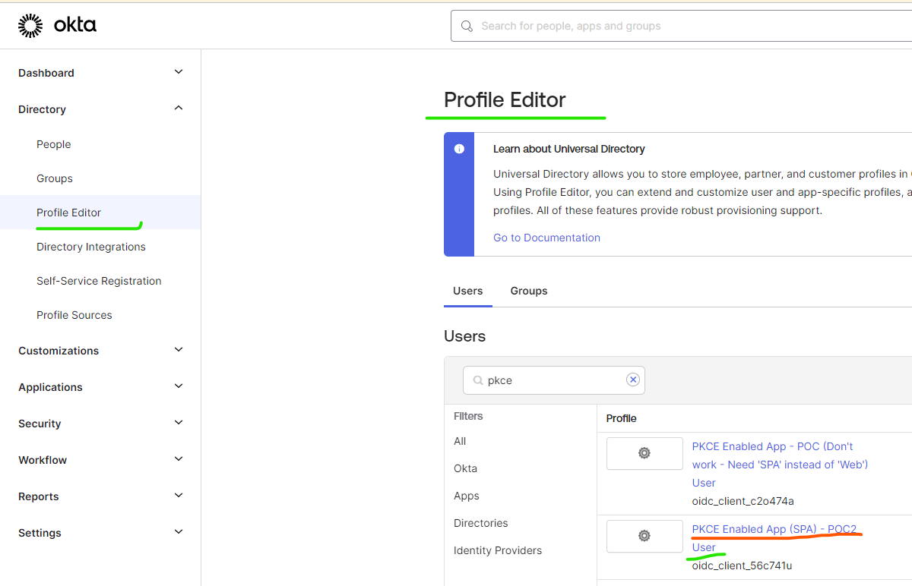

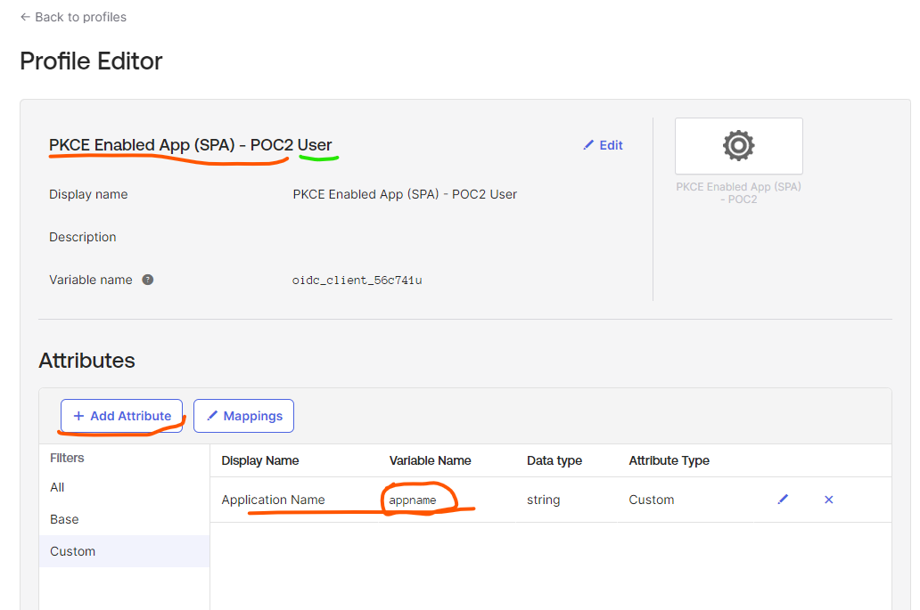

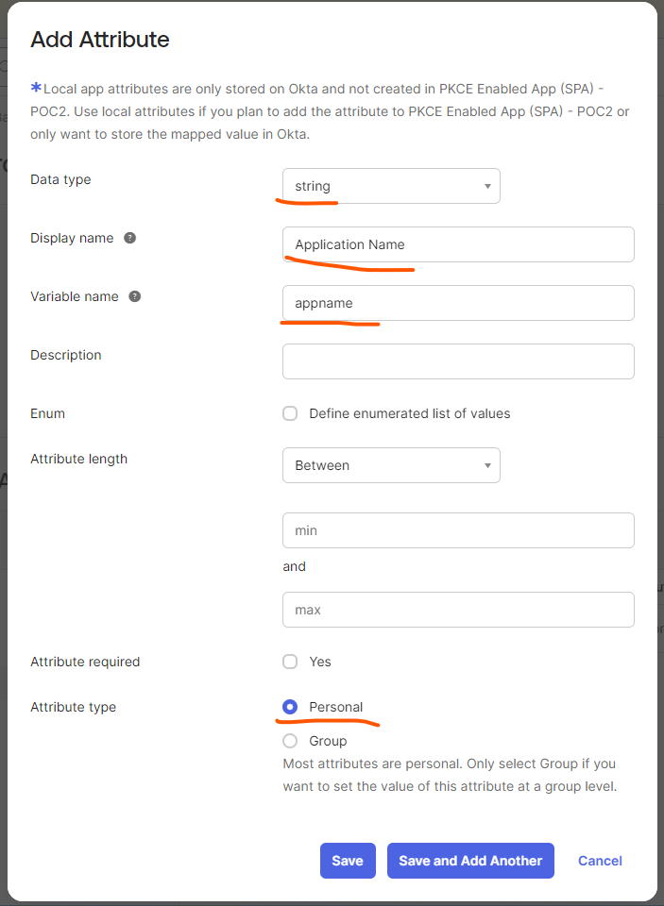

Stage 1.1

Set custom claim the desired value (Profile Editor=>Mapping)

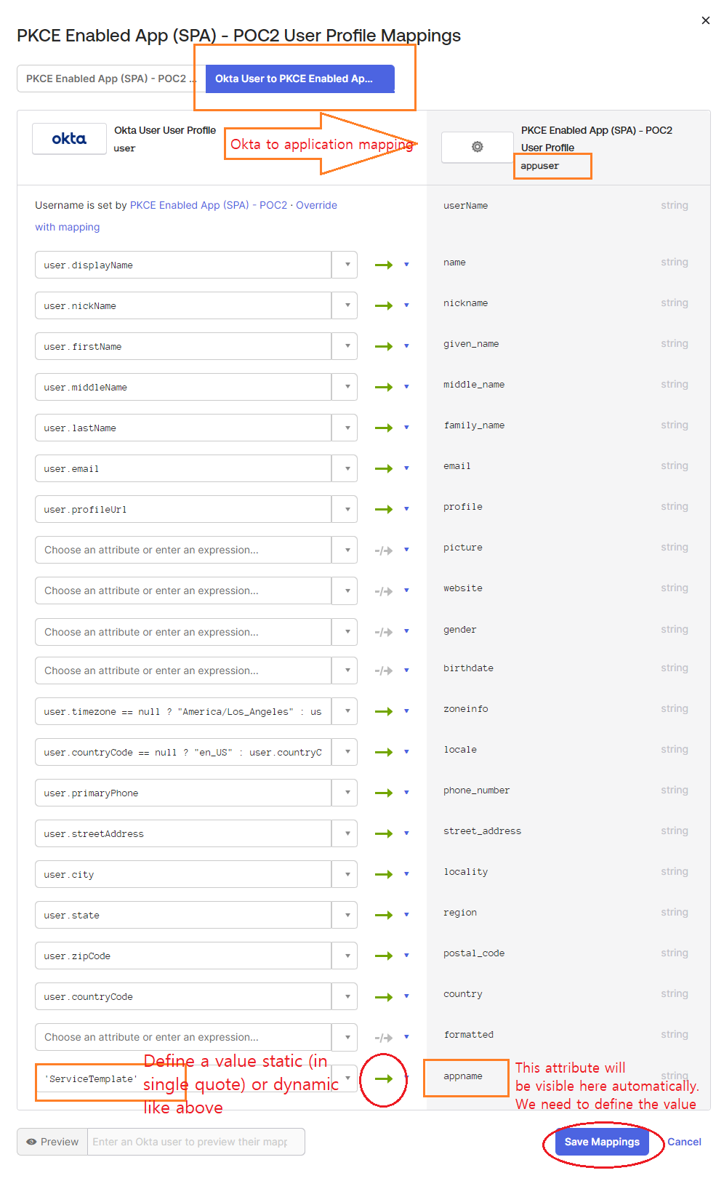

NOTE: Use single quote for static value above

Stage 2

Configure Auth Server to include the custom claims into Tokens



